**ALGORITHMS AND FLOWCHARTS**

1. Check if the given number is Even or Odd

**Flowchart:**

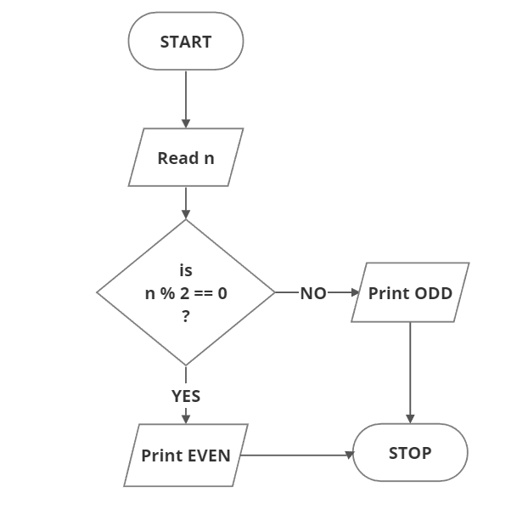

**Algorithm:**

* 1. Start
  2. Read n
  3. Check if n%2 is equal to 0
* If YES, then Print “EVEN”,
* If NO, then Print “ODD”
  1. Stop

1. Write a Program in Java to find the factorial of a given number

**Flowchart:**

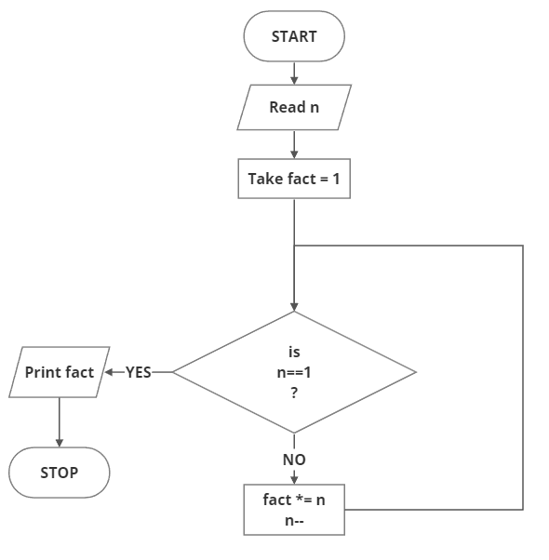

**Algorithm:**

* 1. Start
  2. Read n
  3. Let fact = 1
  4. While n is not equal to 1

fact *= n

n = n – 1;

* 1. Print fact
  2. End

1. Find the factorial of a number using recursion

**Flowchart:**



**Algorithm:**

* 1. Start
  2. Read n
  3. Call factorial(n)
  4. If n is equal to 1

return 1

else

return n * factorial(n-1)

* 1. Print what is returned
  2. End

1. Swap two numbers without using a third variable approach

**Flowchart:**

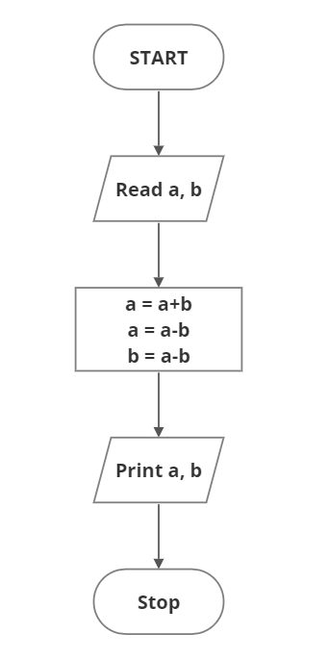

**Algorithm:**

* 1. Start
  2. Read a, b
  3. Perform

a = a+b

a = a-b

b = a-b

* 1. Print a,b
  2. Stop

1. How to check whether the given number is Positive or Negative in Java

**Flowchart:**

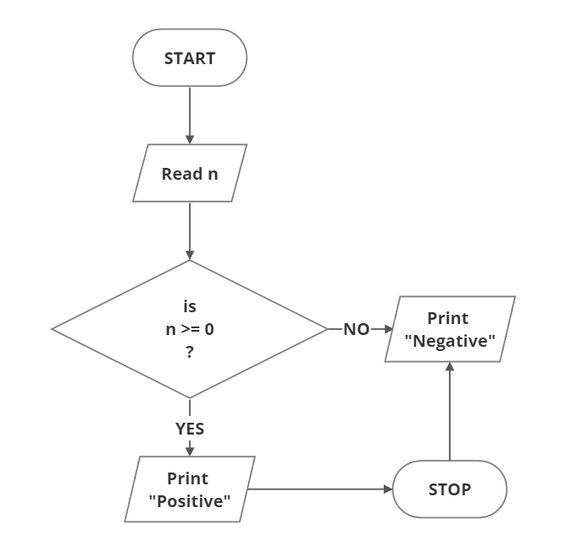

**Algorithm:**

* 1. Start
  2. Read n
  3. If n>=0

Then print “POSITVE”

Else

Print “NEGATIVE”

* 1. Stop

1. Write a Java program to find whether a given number is leap year or not

**Flowchart:**

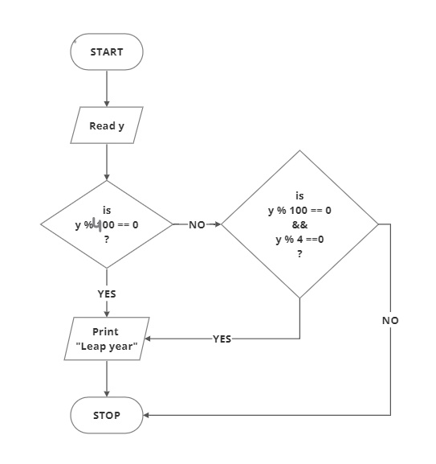

**Algorithm:**

* 1. Start
  2. Read y
  3. If y%100 == 0

Then print “Leap year”

else check If (y%100==0 && y%4==0)

If YES, then print “Leap Year”

IF No, print “Not Leap Year”

* 1. Stop

1. Write a program to print 1 to 10 without using loops

**Flowchart:**

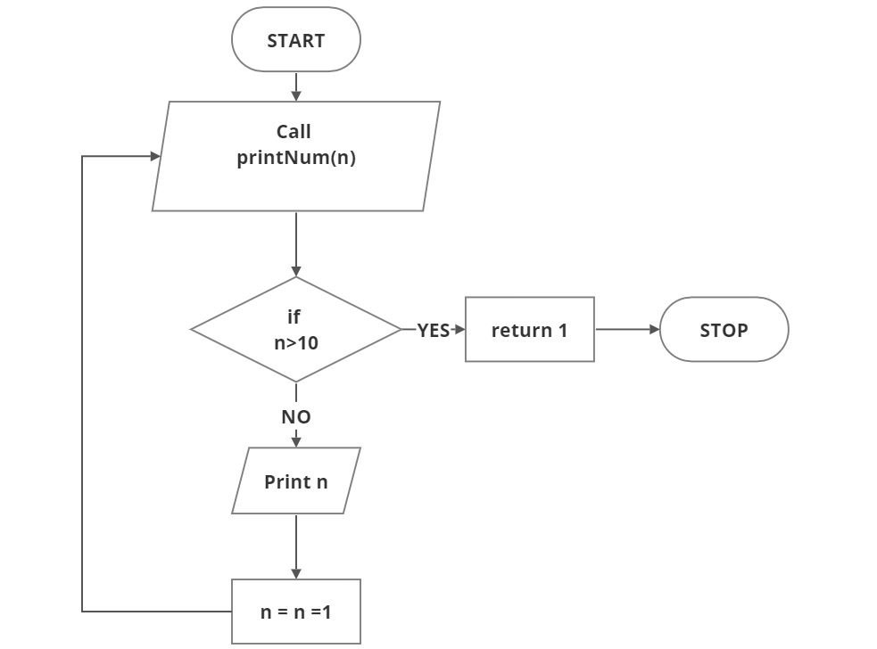

**Algorithm:**

* 1. Start
  2. Call printNum function passing n as argument
  3. In function, check if n>10

if YES, return 1 from where it was called

if NO, print n and call function with argument (n-1)

* 1. STOP

1. Write a java program to print the digits of a given number

**Flowchart:**

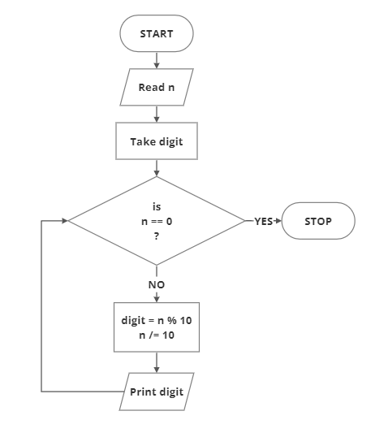

**Algorithm:**

* 1. Start
  2. Read n
  3. While n==0

digit = n%10

n /= 10

* 1. Print digit
  2. Stop

1. Write a java program to print all the factors of a given number

**Flowchart:**

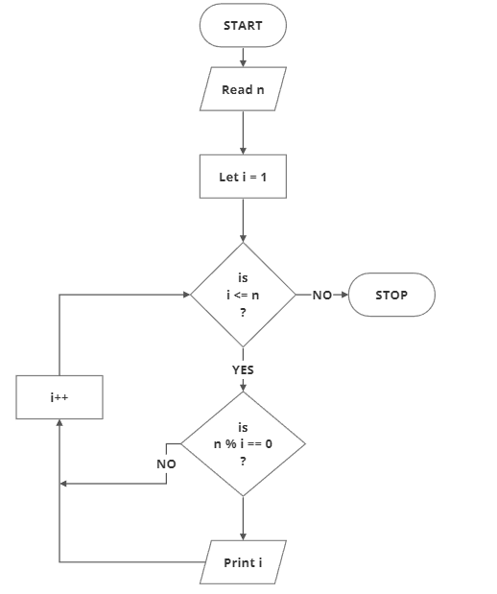

**Algorithm:**

* 1. Start
  2. Read n
  3. Set i=1
  4. While i<=n

Check n%i == 0

If true

print i

Else

Increment i

* 1. End

1. Write a java program to find the sum of the digits of a given number

**Flowchart:**

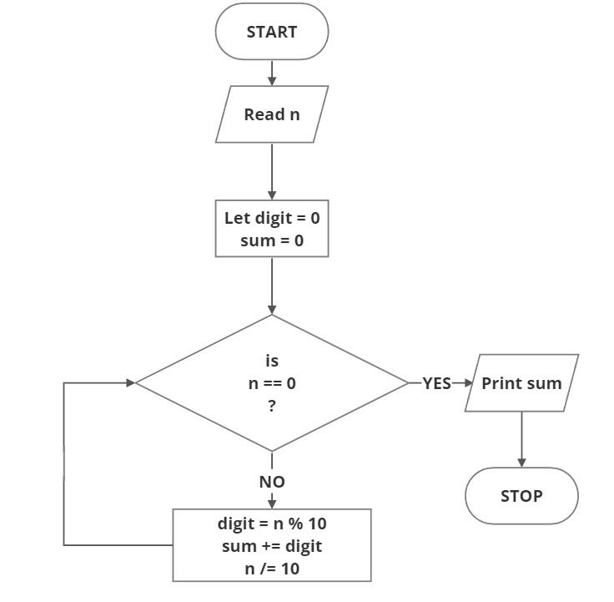

**Algorithm:**

* 1. Start
  2. Set sum=0
  3. While n != 0

Digit=n%10

Sum+=digit

n/=10

* 1. Print sum
  2. End

1. Write a java program to find the smallest of 3 numbers (a, b, c)

**Flowchart:**

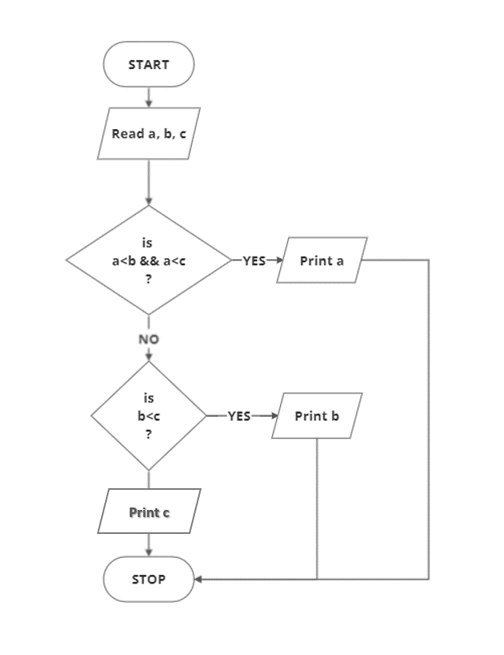

**Algorithm:**

* 1. Start
  2. Read a, b, c
  3. If a<b && a<c

Print a

Else If b<c

Print b

Else

Print c

* 1. End

1. How to add two numbers without using arithmetic operators in Java

**Flowchart:**

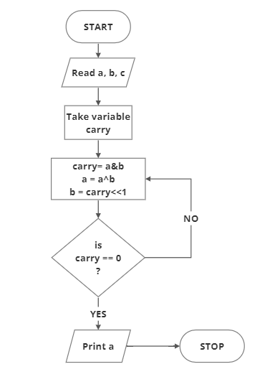

**Algorithm:**

* 1. Start
  2. Read a, b, c
  3. While carry != 0

Carry = a&b

a=a^b

b=carry<<1

* 1. Print a
  2. Stop

1. Write a java program to reverse a given number

**Flowchart:**

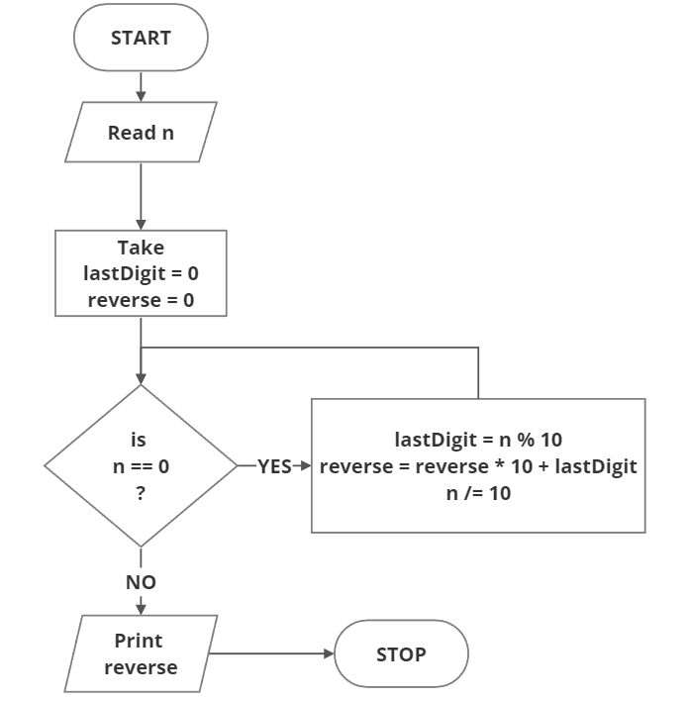

**Algorithm:**

* 1. Start
  2. Read n
  3. While n != 0

Lastdigit=n%10

Reverse= reverse*10 + lastdigit

n/=10

* 1. Print reverse
  2. End

1. Write a java program to find the GCD of two given numbers

**Flowchart:**

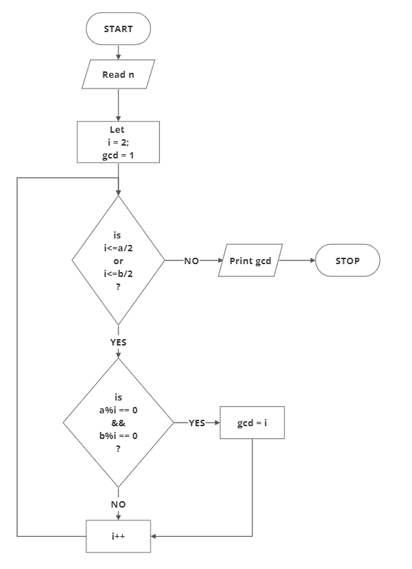

**Algorithm:**

* 1. Start
  2. Read n
  3. Set i=2, gcd = 1
  4. While i<=a/2 or i<=b/2

If a%10==0 && b%10==0

Then gcd = 1

Else increment i

* 1. Print gcd
  2. End

1. Write a java program to find the LCM of two given numbers

**Flowchart:**

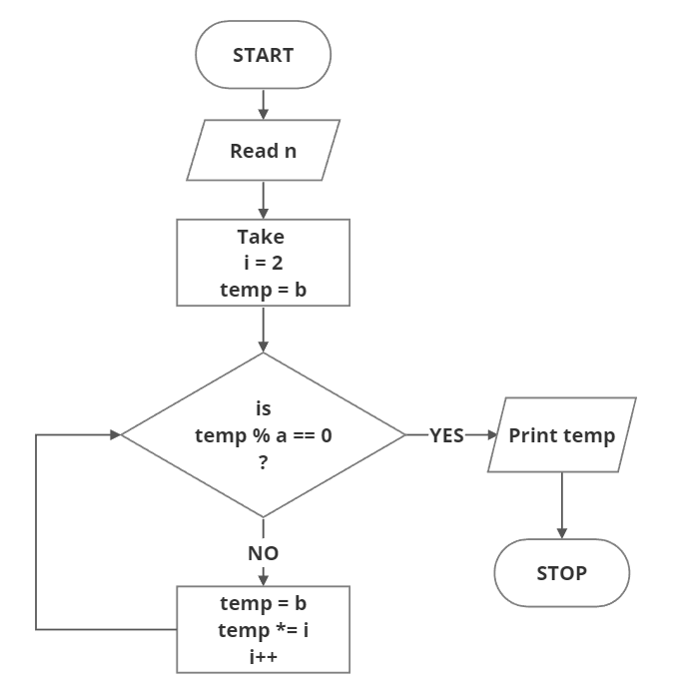

**Algorithm:**

* 1. Start
  2. Read n
  3. Set temp=b and i=2
  4. While temp%a != 0

temp=b

temp *= i

i++

* 1. Print temp
  2. End

1. Check whether the given number is a palindrome or not

**Flowchart:**

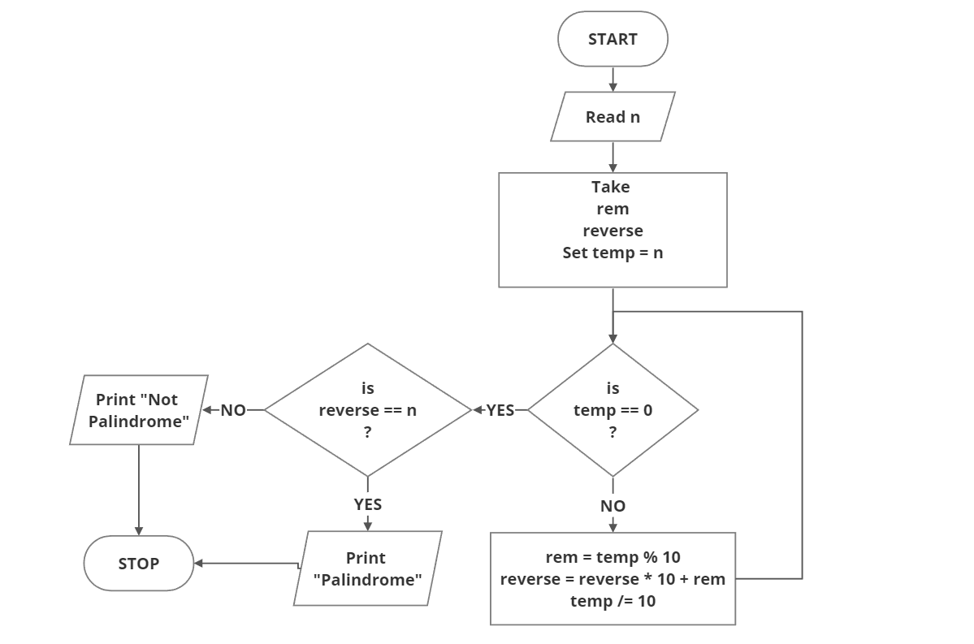

**Algorithm:**

* 1. Start
  2. Read n
  3. Set temp = n
  4. While temp != 0

rem = temp%10

reverse = reverse*10 + rem

temp /= 10

* 1. If reverse == n

Print “Palindrome”

Else

Print “Not Palindrome”

* 1. End

1. Write a java program to print all the Prime Factors of a given number

**Flowchart:**

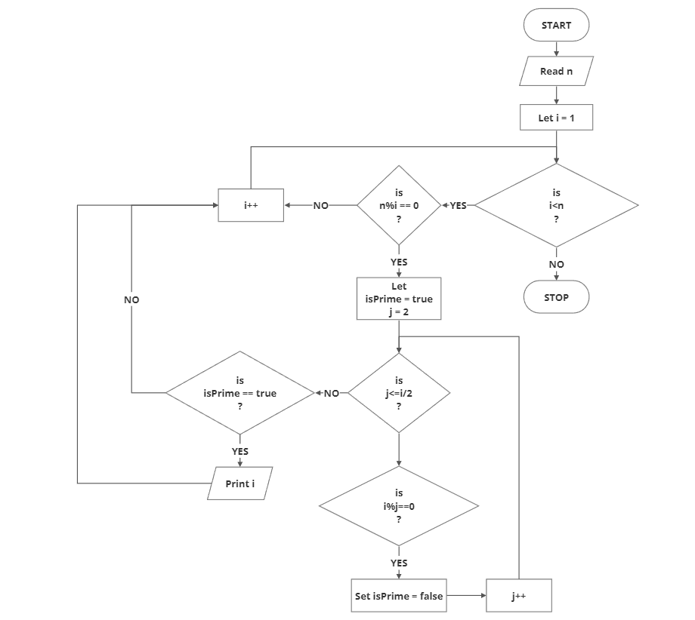

j++

**Algorithm:**

* 1. Start
  2. Read n
  3. While i<=n
* If n%i==0

Set isPrime = true and j = 2

Else increment i

* While j<=i/2
  + If i%j == 0 
    - Set isPrime = false
    - Break loop
* Else
  + Increment j
* Check if isPrime=true, then Print i

Else increment i

* 1. Stop

1. Write a program to print the following EVEN series 2,4,6,8,10,12…..

**Flowchart:**

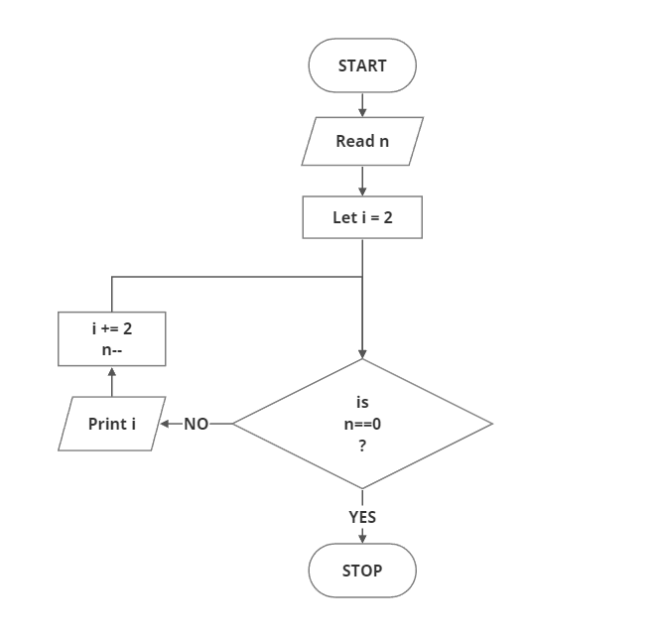

**Algorithm:**

* 1. Start
  2. Read n
  3. Set i=2
  4. While n != 0

Print i

i+=2

n = n-1

* 1. End

1. Write a program to print the following ODD series 1,3,5,7,9,……

**Flowchart:**

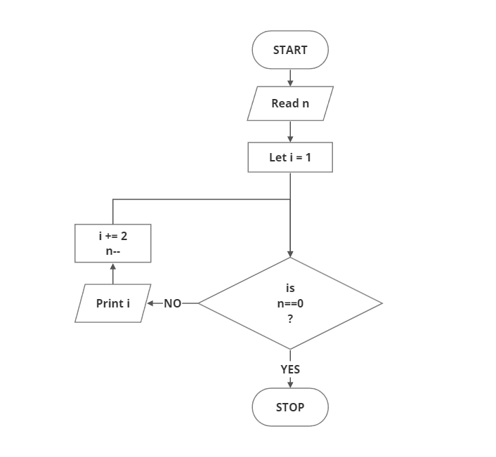

**Algorithm:**

* 1. Start
  2. Read n
  3. Set i=1
  4. While n != 0

Print i

i+=2

n = n-1

* 1. End